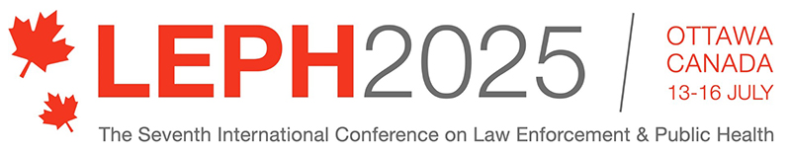

ABSTRACT SUBMISSION FORM for Oral and Poster Presentations
Abstract Title:
Author:
Position and affiliation:
Contact email address:
Other authors and affiliations:
Presentation format: Oral Poster
Tick which conference theme(s) best suits your presentation?
Determinants of health and criminalization that impact LEPH; criminalization of
communities and public health issues: the role of the law enforcement sector
Communities and context supportive of the LE and PH partnership
Recruiting, training and education of law enforcement and public health personnel:
for public health policing, and for engagement of police as public health stakeholders
Trauma-informed approaches to policing, public health, childhood adversity and early
intervention: what does trauma-informed awareness mean for practice?
Police health, mental health and wellbeing: wellness and resilience of police and other
first responders
Neurodisability and LE: early identification, support, and interventions to prevent harm
Violence prevention: LEPH systemic approaches to prevent violence
The challenges and successes of partnering for whole systems change

Other – specify:

Is your presentation part of a convened session? If so, who is the convener?

Would you like a full version of your presentation to be considered for publication in the Journal of Community Safety and Wellbeing’s special conference issue? Yes No

ABSTRACT - 150 words maximum covering:

Background:

Research Objectives:

Methods:

Results:

Conclusions or Implications:

ABSTRACTS CLOSE ON 31 March 2025

